**Pizza Shop App**



**Session 2023 – 2027**

**Submitted by:**

Biya Anjum 2023-CS-82

Areeba Abid 2023-CS-58

Arfa Amir 2023-CS-64

**Supervised by:**

Sir Nazeef Ul Haq

**Course:**

CSC-200L Data Structures and Alogrithms B

Department of Computer Science

University of Engineering and Technology,

Lahore Pakistan.

**Contents**

1. **Overview 3**
2. Description ……………………………………………............... 3
3. Business Case ……………………………………………………... 3
4. Motivation ……………………………………………………... 3
5. Audience ……………………………………………………... 3
6. Features ……………………………………………………… 3
7. **Technology Stack 3**
8. **Types of Customers 4**
9. **Menu Options & Use Cases 4**
10. Main Menu ………………………………………………………. 4
11. Place Order for Takeaway ……………………………………………….. 4
12. Place Order for Home Delivery ………………………………………….. 5
13. Place Order for Dine-In …………………………………………………. 5
14. Search Served Orders …………………………………………………... 5
15. Total Bill of Pending Orders …………………………………………….. 6
16. Total Earnings …………………………………………………………… 6
17. Serve Orders …………………………………………………………….. 6
18. Display All Orders ……………………………………………………… 6
19. **Implemented Data Structures 7**
20. LinkedList ……………………………………………………….. 7
21. Stack …………………………………………………………….. 7
22. Dynamic Queue …………………………………………………. 7
23. Dynamic Priority Queue ………………………………………… 7
24. Graph ……………………………………………………………… 7
25. AVL Tree …………………………………………………………. 8
26. Dijkastra Alogrithm ………………………………………………. 8
27. **Code Structure 8**
28. Global Variable …………………………………………………… 8
29. Functions ………………………………………………………….. 8
30. Main Menu ………………………………………………………... 8
31. **Strengths 8**
32. Scalability …………………………………………………………. 8
33. Efficiency ………………………………………………………… 8
34. User Friendly Interface …………………………………………… 8
35. **Conclusion 8**
36. **Future Improvements 9**

**Overview:**

The main idea revolves around a Pizza Shop that deals with three different kinds of customers and serves them in different ways. The Project is built assist that small business. It also stores the information of the customers served and the total earnings of the shop. The waiting customers’ info can also be displayed. Searching for the served Customers can be done. The delivery charges are calculated on the basis of the shortest distance on the map and 50 RS_/ per KM is charged as delivery charges.

* **Business Case:**

This project serves pizza shop owners by simplifying order placement, serving, billing, and record-keeping. It reduces human error, enhances service quality, and provides a systematic approach to managing orders and deliveries. Additionally, it supports revenue tracking and customer data management for better decision-making.

* **Motivation:**

The project aims to address the inefficiencies of manual pizza shop operations, where errors and delays can affect customer satisfaction. By automating these processes, the system ensures faster order handling, accurate billing, and seamless delivery services. It leverages algorithms and data structures to optimize performance and customer experience.

* **Audience:**

This system is tailored for small to medium-sized pizza shops that want to digitize their operations. It can also be adapted for other small-scale restaurants or businesses with similar order management needs.

* **Features:**
* Order management for three customer types: take-away, dine-in, and home delivery.
* Priority-based serving: FIFO for dine-in, LIFO for home delivery, and age-priority for take-away.
* Dynamic billing, including menu-based pricing and additional charges for delivery.
* A record-keeping system using AVL trees for served customers, supporting search and display of order history.
* Display and calculation of total pending bills and total earnings.
* Graph-based delivery distance calculation using Dijkstra's algorithm.

**Technology Stack:**

|  |  |
| --- | --- |
| Programming Language | C++ |
| Data Structures | AVL Trees, Priority Queue, Stack, Linked List, Graphs. |
| Alogrithms | Dijkstra's algorithm |
| User Interface | Command Line Interface |

**Types of Customers:**

|  |  |
| --- | --- |
| Walk-In Customers | They will be served on the basis of their age. The older customer will be served first. |
| Home Delivery Customers | They will be served on the basis of LIFO. |
| Dine-In Customers | They will be served on the basis of FIFO |
| Served Customers | The Customers which are served are recorded in the System to keep the record of the served Customers and their bills so that we may have insights into the daily sales of the shop. Its main purpose is to check the record of a particular Customer. |

## Menu Options and Use Cases:

Below are detailed descriptions of the main menu options, their functionalities, and their users.

### Main Menu:

|  |  |
| --- | --- |
|  |  |

### Place Order for Take-Away Customer:

|  |  |
| --- | --- |
| Menu Option | Place Order for Take-Away Customer |
| Accessible By | Customers (Take-Away Customers) |
| Description | Allows take-away customers to place orders by providing their details, selecting pizzas, and specifying the quantity. Total bill is calculated automatically. |
| UI Placeholder |  |

### Place Order for Home Delivery Customer:

|  |  |
| --- | --- |
| Menu Option | Place Order for Home Delivery Customer |
| Accessible By | Customers (Home Delivery Customers) |
| Description | Enables home delivery customers to place orders, specify delivery addresses, and calculate delivery charges based on distance using Dijkstra's algorithm. |
| UI Placeholder |  |

### Place Order for Dine-In Customer:

|  |  |
| --- | --- |
| Menu Option | Place Order for Dine-In Customer |
| Accessible By | Customers (Dine-In Customers) |
| Description | Allows dine-in customers to place orders by selecting items and quantities. Total bill is calculated. |
| UI Placeholder |  |

### Search Served Orders:

|  |  |
| --- | --- |
| Menu Option | Search Served Orders |
| Accessible By | Shop Staff |
| Description | Shop staff can search served orders for all customer types based on customer name. |
| UI Placeholder |  |

### Total Bill of Pending Orders:

|  |  |
| --- | --- |
| Menu Option | Total Bill of Pending Orders |
| Accessible By | Shop Staff |
| Description | Calculates the total pending bills across all customer types and displays the summary. |
| UI Placeholder |  |

### Total Earnings:

|  |  |
| --- | --- |
| Menu Option | Total Earnings |
| Accessible By | Shop Staff |
| Description | Calculates and displays total earnings from served orders stored in the AVL Tree. |
| UI Placeholder |  |

### Serve Orders:

|  |  |
| --- | --- |
| Menu Option | Serve Orders |
| Accessible By | Shop Staff |
| Description | Shop staff can serve pending orders for all customer types based on predefined priorities (e.g., age, FIFO, LIFO). |

### Display All Orders:

|  |  |
| --- | --- |
| Menu Option | Display All Orders |
| Accessible By | Shop Staff |
| Description | Displays all pending orders for take-away, dine-in, and home delivery customers. |

**Implemented Data Structures:**

1. **LinkedList:**

The whole implementation of Customer’s Enqueue and dequeue is based on the LinkedList.

1. **Stack:**

It is used in placing orders and serving Home Delivery Customers.

1. **Dynamic Queue:**

It is used in placing orders and serving Dine-In Customers.

1. **Dynamic Priority Queue:**

It is used in placing orders and serving Walk-In Customers.

1. **Graph:**

It is used for the Map for available Delivery options.

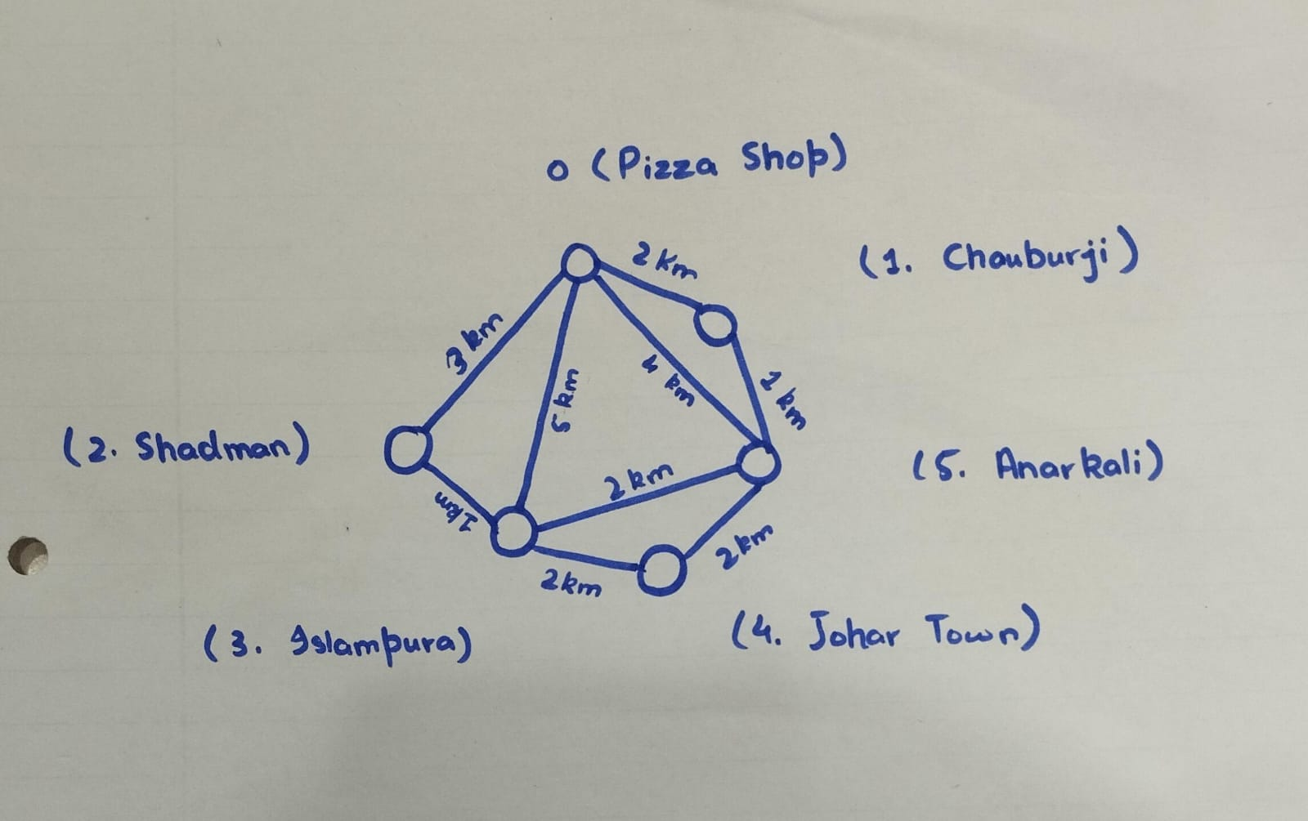

1. **AVL Tree:**

The Served Customers were saved in it for efficient insertion, deletion and searching. The implementation was based upon the lexicographical comparison of strings.

1. **Dijkstra Alogrithm:**

It is used to find the shortest possible distance from the Pizza Shop and on this basis, the Delivery charges are calculated.

#### **Code Structure:**

1. **Global Variables**:

The program uses several global variables to manage state, such as pointers to different customer queues and financial summaries.

1. **Functions**:

Modular functions handle specific tasks like placing orders, serving orders, AVL tree operations, and graph traversal.

1. **Main Menu**:

A menu-driven interface allows users to interact with the system by choosing options for various operations.

#### **Strengths**

1. **Scalability**:

The modular structure and use of advanced data structures like AVL trees and graphs make the system scalable for more complex scenarios.

1. **Efficiency**:

Efficient algorithms ensure fast order placement, serving, and delivery charge calculations.

1. **User-Friendly Interface**:

The menu-driven approach makes it easy for users to navigate through options.

#### **Conclusion:**

The Pizza Shop App is a robust solution for managing customer orders and services in a pizza shop. Its modular design and use of efficient data structures ensure scalability and reliability. By implementing suggested improvements, such as better memory management and error handling, the system could be further refined to handle larger operations and adapt to real-world requirements.

#### **Future Improvements**

Future enhancements to the Pizza Shop App could include the integration of a graphical user interface (GUI) to improve the overall user experience, along with mobile application support for remote order placement. Adding online payment options through payment gateways would streamline transactions for take-away and home delivery customers. Additionally, real-time analytics could provide insights into order trends, customer preferences, and financial performance. Expanding the system to support multiple branches would enable centralized management across locations, while implementing user accounts could allow customers to personalize their experience and access order histories easily.